Pokhara University

Level: Bachelor | Semester – Fall | Year : 2011
Programme: BE |  | Full Marks: 100
Course: Numerical Methods |  | Pass Marks: 45
 |  | Time : 3hrs.

Candidates are required to give their answers in their own words as far as practicable.
The figures in the margin indicate full marks.

Attempt all the questions.

 | - Find the root of the equation 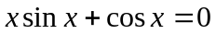 with accuracy 0.008, using False Position method.  - Using Secant method find a root of the equation 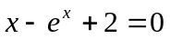correct to three decimal places. | 8  7
 | - Prove that the Newton Raphson method is quadratic convergent.  Estimate the value of sinθ at θ = 25 uisng Netwon- Gregory forward difference formula with the help of the following table: | 7  8
  θ | 10 | 20 | 30 | 40 | 50
  sinθ | 0.1736 | 0.3420 | 0.5000 | 0.6428 | 0.7660
 | - Determine the constants a and b by the method of least square such that 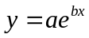 fits the following data:  x : 2 4 6 8 10  y : 4.077 11.084 30.128 81.897 222.62  - Evaluate the integral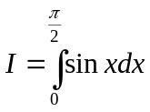. Compare the result in both conditions for Simpson1/3 and 3/8 rule. | 7  8
 | - Solving the following system of Linear equations using L-U factorisation method.  5x – 2y + z = 4,  7x + y – 5z = 8,  3x + 7y + 4z = 10.  - Using Gauss-Seidel iteration method solve:  2x - 7y - 10z = -17,  5x + y + 3z = 14  x + 10y + 9z = 7 | 8  7
 | - Solve the following differential equation within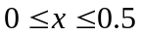 using RK 4th order method. 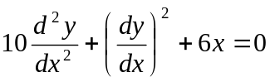, with 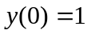and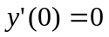. (take h=0.25)  - Solve the Poission equation 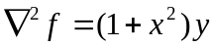, over the square domain of 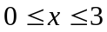 and 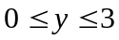 with 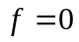 and 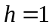. | 8  7
 | - Use Power method to find the largest Eigen value and corresponding Eigen vector for the following matrix.  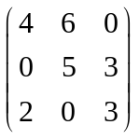  - Solve the Laplace’s equation U_{xx} + U_{yy} = 0 in the domain of the figure given below:  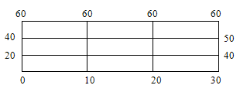 | 7  8
 | Write short notes on any two:  - Romberg integration  - Cubic spline interpolation  - Laplacian equation | 2×5

